

**Data Visualization PROJECT REPORT**

**(Project Semester August-December 20)**

**Submitted by**

**Mukkara Manasa**

**Registration No: 12210172**

**Data Science and K22ZM**

**INT 233**

**Under the Guidance of**

**Ashu : 23631**

**Discipline of CSE/IT**

**Lovely School of Computer Science and Engineering**

**Lovely Professional University, Phagwar**

**Dashboard Name**

**Spark of Sales: Electronics Performance Insights**

The "Spark of Sales" dashboard is a comprehensive analytics tool designed to provide actionable insights into customer purchase behaviours in the electronics market. It leverages a dataset sourced from **Kaggle** under the theme **Customers Purchase Behaviour – Electronics**. The dataset includes rich details on product types (e.g., **Smartphones**, **Laptops**, **Tablets**, **Smartwatches**, and **Headphones**), SKUs, ratings, add-ons, and payment methods.

**Purpose of the Dashboard:**

The primary aim of this dashboard is to:

* **Identify** high-performing products across categories.
* **Analyze** sales trends based on demographics, payment types, and purchase behaviors.
* **Optimize** marketing strategies and inventory management based on customer preferences.
* The "Spark of Sales" dashboard is a comprehensive analytics tool designed to provide actionable insights into customer purchase behaviours in the electronics market. It leverages a dataset sourced from **Kaggle** under the theme **Customers Purchase Behaviour – Electronics**. The dataset includes rich details on product types (e.g., **Smartphones**, **Laptops**, **Tablets**, **Smartwatches**, and **Headphones**), SKUs, ratings, add-ons, and payment methods.
* **Purpose of the Dashboard:**

The primary aim of this dashboard is to:

1. **Bubble Chart:** Highlights the highest-rated products by product type.
2. **Stacked Bar Chart:** Analyzes sales distribution by gender and age group.
3. **Donut Chart:** Explores product types by payment methods.
4. **Dual-axis:** Shows add-ons distribution by product type and SKU.
5. **Heat Map:** Tracks the quantity of product types sold over time.
6. **Area Chart:** Examines cumulative product purchases over time.

These visualizations enable businesses to make informed decisions by focusing on the most impactful areas of customer behaviour and sales performance.

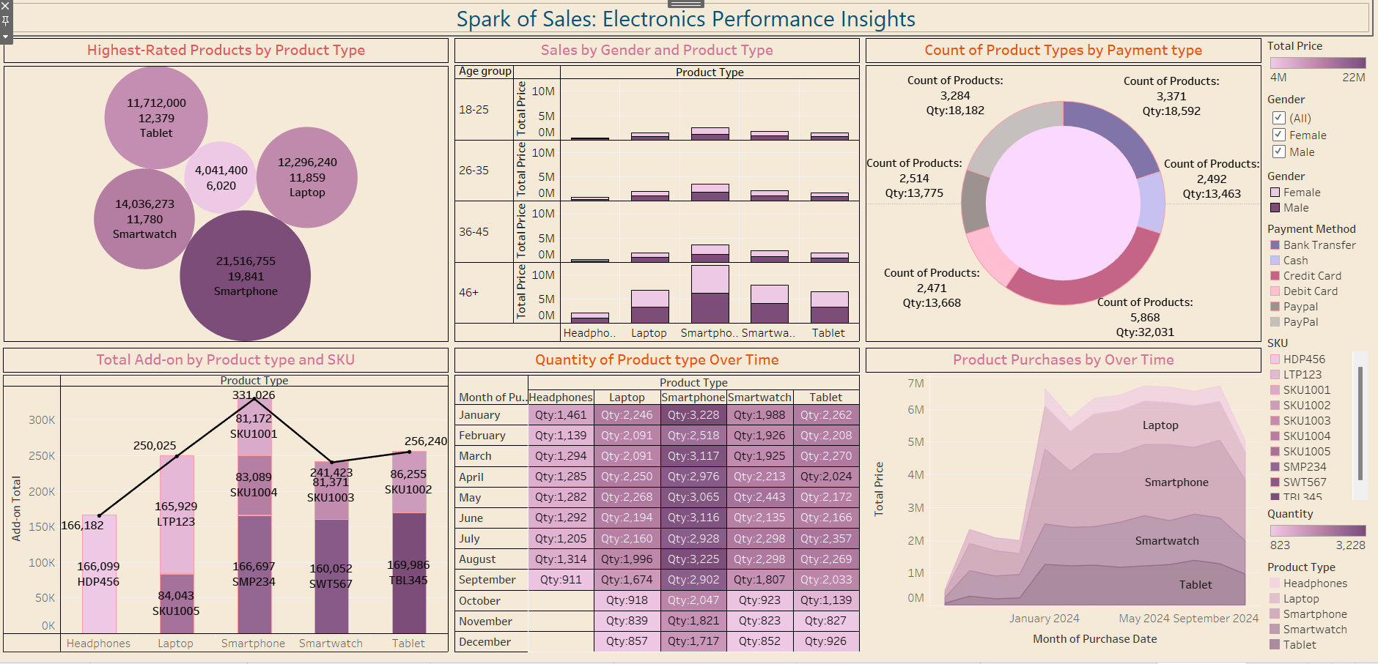

**Bubble Chart – Highest Rated Products by Product Type**

The **Bubble Chart** focuses on the highest-rated products, with bubbles sized based on ratings and grouped by product type. Examples from the dataset include:

* **Smartphone SKU1001** with a 4.8 rating.
* **Laptop LTP123** with a 4.5 rating.
* **Smartwatch SWT567** with a 4.6 rating.

**Purpose:**  
To help identify top-performing products, giving businesses a clear view of customer satisfaction and enabling targeted marketing for high-rated products.

**Insights:**

* **Smartphones** consistently receive high ratings, particularly **SKU1001**, making it a standout performer.
* **Laptops (LTP123)** are another strong category, indicating customer satisfaction with this product line.

**Actionable Recommendations:**

* Promote highly rated products like **Smartphone SKU1001** and **Laptop LTP123** in marketing campaigns.
* Use these insights to improve customer experience for lower-rated products.

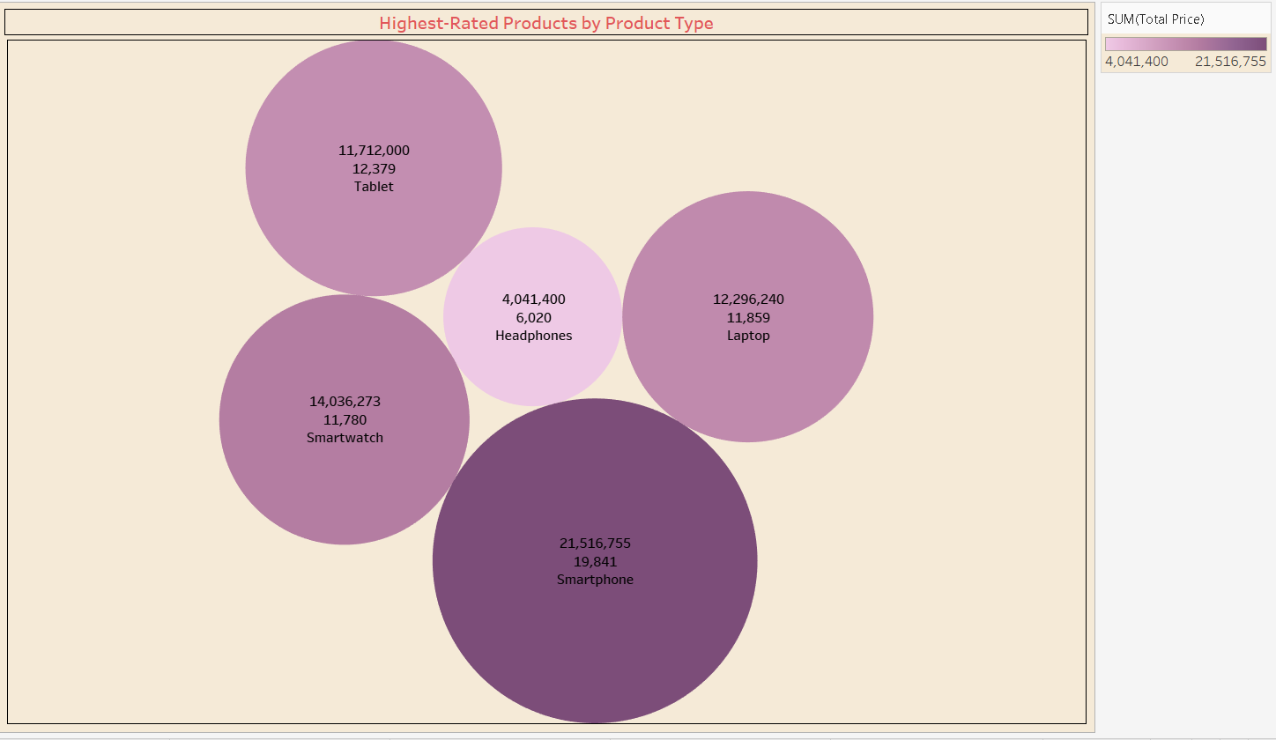

**Stacked Bar Chart – Sales by Gender and Age Group**

The **Stacked Bar Chart** provides a demographic analysis of sales, categorized by gender and age group. The age groups are divided into **18-25**, **26-35**, **36-45**, and **46+**, offering a detailed segmentation of customer preferences.

**Purpose:**  
To understand how gender and age influence purchasing decisions, enabling tailored marketing strategies.

**Insights:**

* The **26-35** age group contributes significantly to sales, particularly for **Smartphones (SKU1005)** and **Laptops (SKU1004)**.
* **Headphones (HDP456)** are a popular choice across all age groups and genders.

**Actionable Recommendations:**

* Focus marketing efforts on the **26-35** demographic, emphasizing popular products like **Smartphones and Laptops**.
* Offer discounts or bundles for **Headphones** to attract a wider audience.

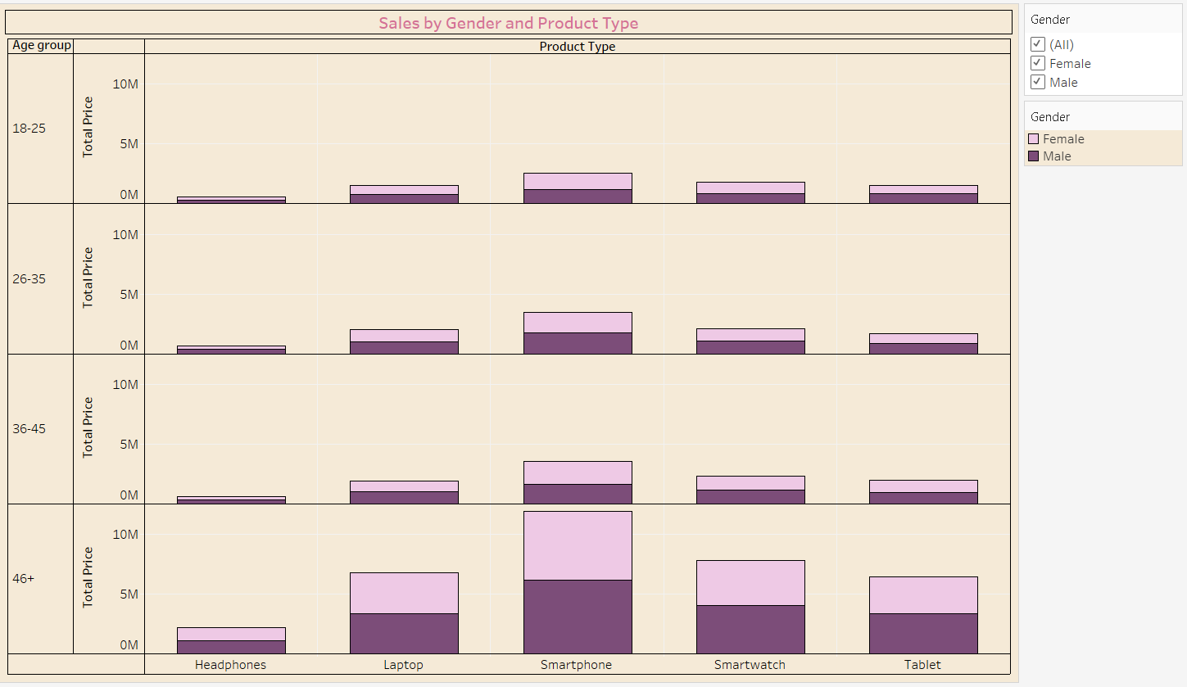

**Donut Chart – Product Types by Payment Method**

The **Donut Chart** visualizes the distribution of payment methods for various product types. The dataset reveals:

* **Smartphones (SMP234)** are frequently purchased with **Credit Cards**.
* **Tablets (TBL345)** show a preference for **PayPal**.
* **Headphones (HDP456)** are often bought using **Cash**.

**Purpose:**  
To uncover customer payment preferences, helping businesses optimize their payment options.

**Insights:**

* Customers prefer **Bank Transfers** and **Credit Cards** for high-value items like **Laptops (LTP123)**.
* Smaller items like **Headphones** are more likely to be paid for using **Cash**.

**Actionable Recommendations:**

* Enhance payment flexibility by promoting digital wallets and installment options for high-value products.
* Offer cash discounts for smaller items to drive sales.

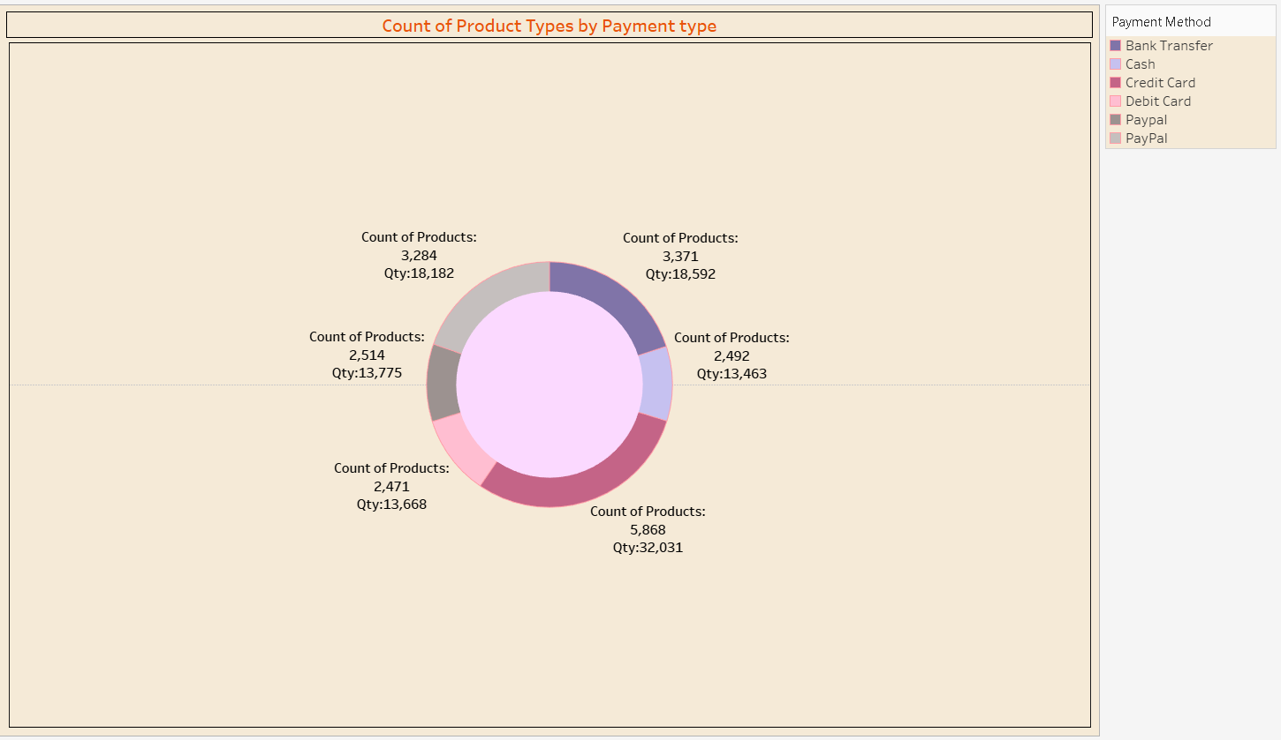

**Pareto Chart – Add-ons by Product Type and SKU**

The **Pareto Chart** examines the contribution of add-ons by product type and SKU. Key insights include:

* **Smartphones (SKU1005)** account for a significant share of add-on sales, such as chargers and cases.
* **Laptops (LTP123)** are another top contributor, with accessories like bags and external drives.

**Purpose:**  
To identify which products drive the majority of add-on sales and plan inventory accordingly.

**Insights:**

* Over **80% of add-ons** are associated with **Smartphones and Laptops**, highlighting their profitability.

**Actionable Recommendations:**

* Bundle popular add-ons with **Smartphones and Laptops** to increase average order value.
* Focus on improving add-on sales for underperforming categories like **Tablets**.

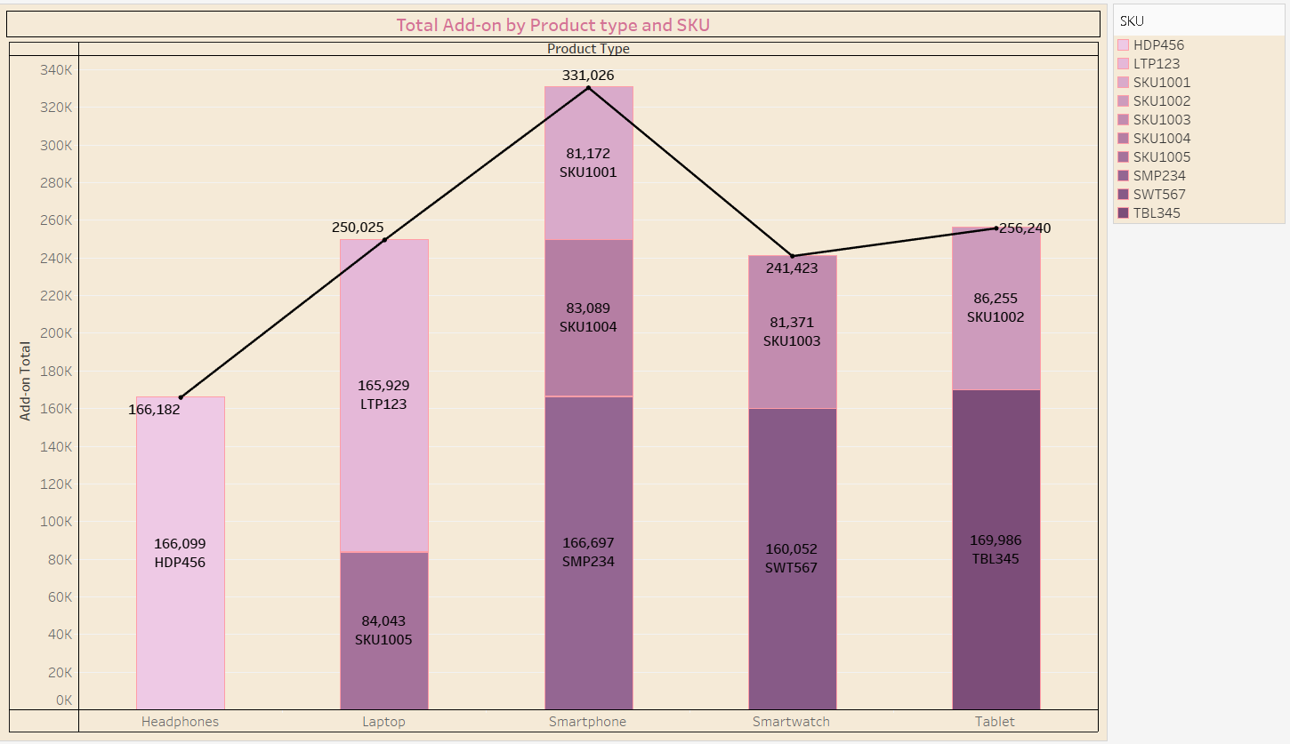

**Heat Map – Quantity of Product Types Sold Over Time**

The **Heat Map** captures sales quantities over time, revealing patterns in customer demand.

**Insights:**

* **Smartphones (SKU1001)** see a sharp increase in sales during holiday seasons and promotional campaigns.
* **Tablets (TBL345)** maintain steady sales, indicating consistent demand.

**Purpose:**  
To monitor demand fluctuations and align marketing campaigns with peak sales periods.

**Actionable Recommendations:**

* Plan holiday promotions around **Smartphones** to maximize revenue.
* Ensure sufficient stock of **Tablets** year-round to meet consistent demand.

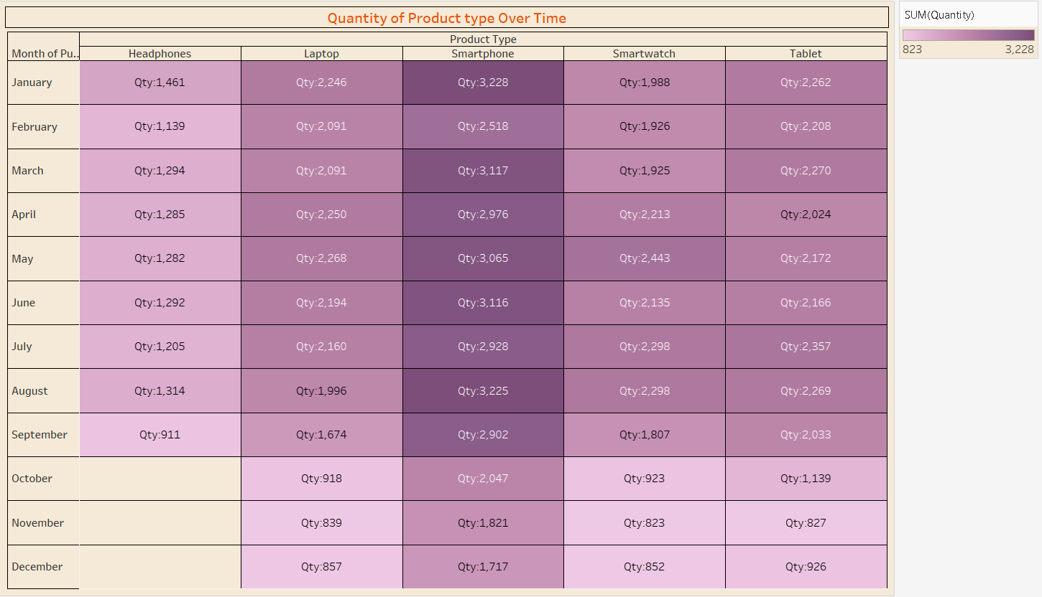

**Area Chart – Product Purchases Over Time**

The **Area Chart** illustrates the growth in product purchases over time, offering a long-term view of performance trends.

**Insights:**

* **Smartwatches (SKU1003)** exhibit rapid growth, reflecting increased interest in wearable technology.
* **Laptops and Smartphones** dominate sales over time, showing their continued importance to the business.

**Purpose:**  
To identify growth areas and allocate resources to maintain momentum.

**Actionable Recommendations:**

* Invest in marketing for emerging categories like **Smartwatches**.
* Strengthen core offerings in **Smartphones and Laptops** to sustain growth.

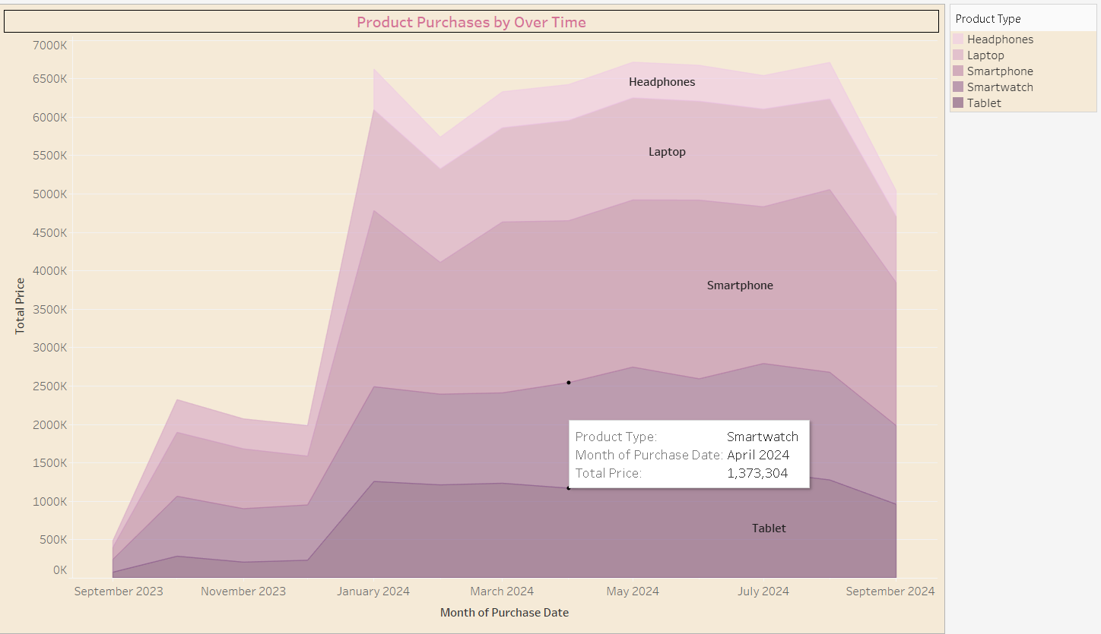

**Conclusion**

The **"Spark of Sales: Electronics Performance Insights"** dashboard combines multiple visualizations to provide a holistic view of sales trends, customer behavior, and product performance.

**Key Takeaways:**

1. **Smartphones and Laptops** are top-performing categories across all metrics.
2. **Smartwatches** show growth potential, warranting additional investment.
3. Seasonal trends and SKU-level insights provide a roadmap for optimizing inventory and marketing efforts.

**Next Steps:**

* Launch targeted promotions for highly rated products like **Smartphone SKU1001**.
* Introduce flexible payment options for premium products like **Laptops**.
* Leverage add-on sales insights to create value-added bundles.

This dashboard empowers businesses to make informed decisions, ensuring sustained growth and enhanced customer satisfaction.